FOR IMMEDIATE RELEASE Contact: Wayne A. Feig
Marketing Director
Phone: +1 206-909-4092
Email: wayne@gerardcycles.com

You Don’t Have to be a Pro to Ride Like One
And with Gerard Cycles you Can
Kirkland, WA USA (June 15, 2021) – Founded in 2013 by Irish-born, ex-pro rider and champion racer John Gerard Sheehan, Gerard Cycles manufactures and builds world-class bikes for a wide range of serious riders. In today’s ever-crowded bicycle marketplace, Gerard Cycles stands out as unique, with a founder who has extensive experience and success in all facets of cycling. As a winning professional bike racer; accomplished cycling coach; expert bike fitter; and someone who’s held various technical positions in the bicycle manufacturing industry, John Gerard Sheehan is a rare commodity.

“Our goal is to build a bike that makes you feel as if you’re one with it and inspires you to ride.”

Competition takes many forms. So even if you’re not contending for a place on the podium, you’re always competing—against the hills, the wind, even your friends. And you’re always competing against yourself. See why serious riders around the world think their Gerard Cycles bikes give them the edge, no matter what kind of ride they take on.

Ride with the Pros
Gerard Cycles relaunches its brand with a new website— www.gerardcycles.com —to promote and support its expanding range of road/race and gravel/adventure bikes. Supported by a growing list of present and past pro riders and champion racers (our Global Ambassadors), Gerard Cycles enjoys a growing reputation for building bikes that win and bikes that last, employing state-of-the-art manufacturing we call G-Spec CarbonProcess™.

How do You Roll?

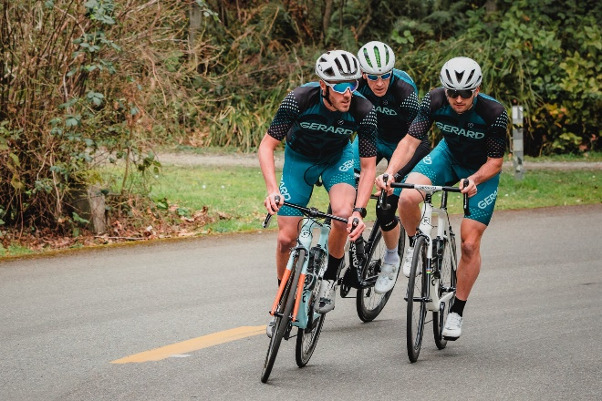
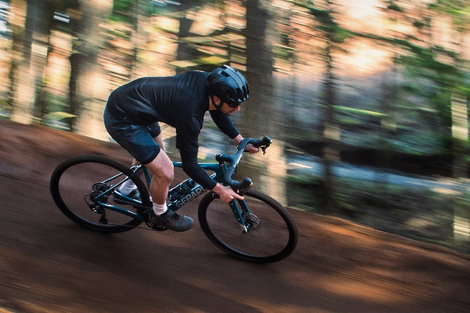
Race, ride hard, or just see where the road takes you. The Gerard Cycles Force 100 is a world-class, carbon-fiber road/race bike.
Available in disc- or rim-brake models with electronic or mechanical shifting.
Roll out on your favorite forest trail or pack up for a week-long escape. The Gerard Cycles TrailForce RX is a carbon-fiber, gravel/adventure bike.
Available with disc brakes and 1x or 2x drivetrains.

Gerard Cycles is an American bicycle company with deep roots in Ireland and Europe. We make the highest quality, carbon-fiber road and gravel bike frames available and provide a range of upgradable stock models or completely customized bikes. Our bikes are fast, beautiful, and fun to ride. You always get Your Bike, Your Way.
###
For more information, call Wayne Feig at +1 206-909-4092 or email wayne@gerardcycles.com.

